Initial Table of Level 2:

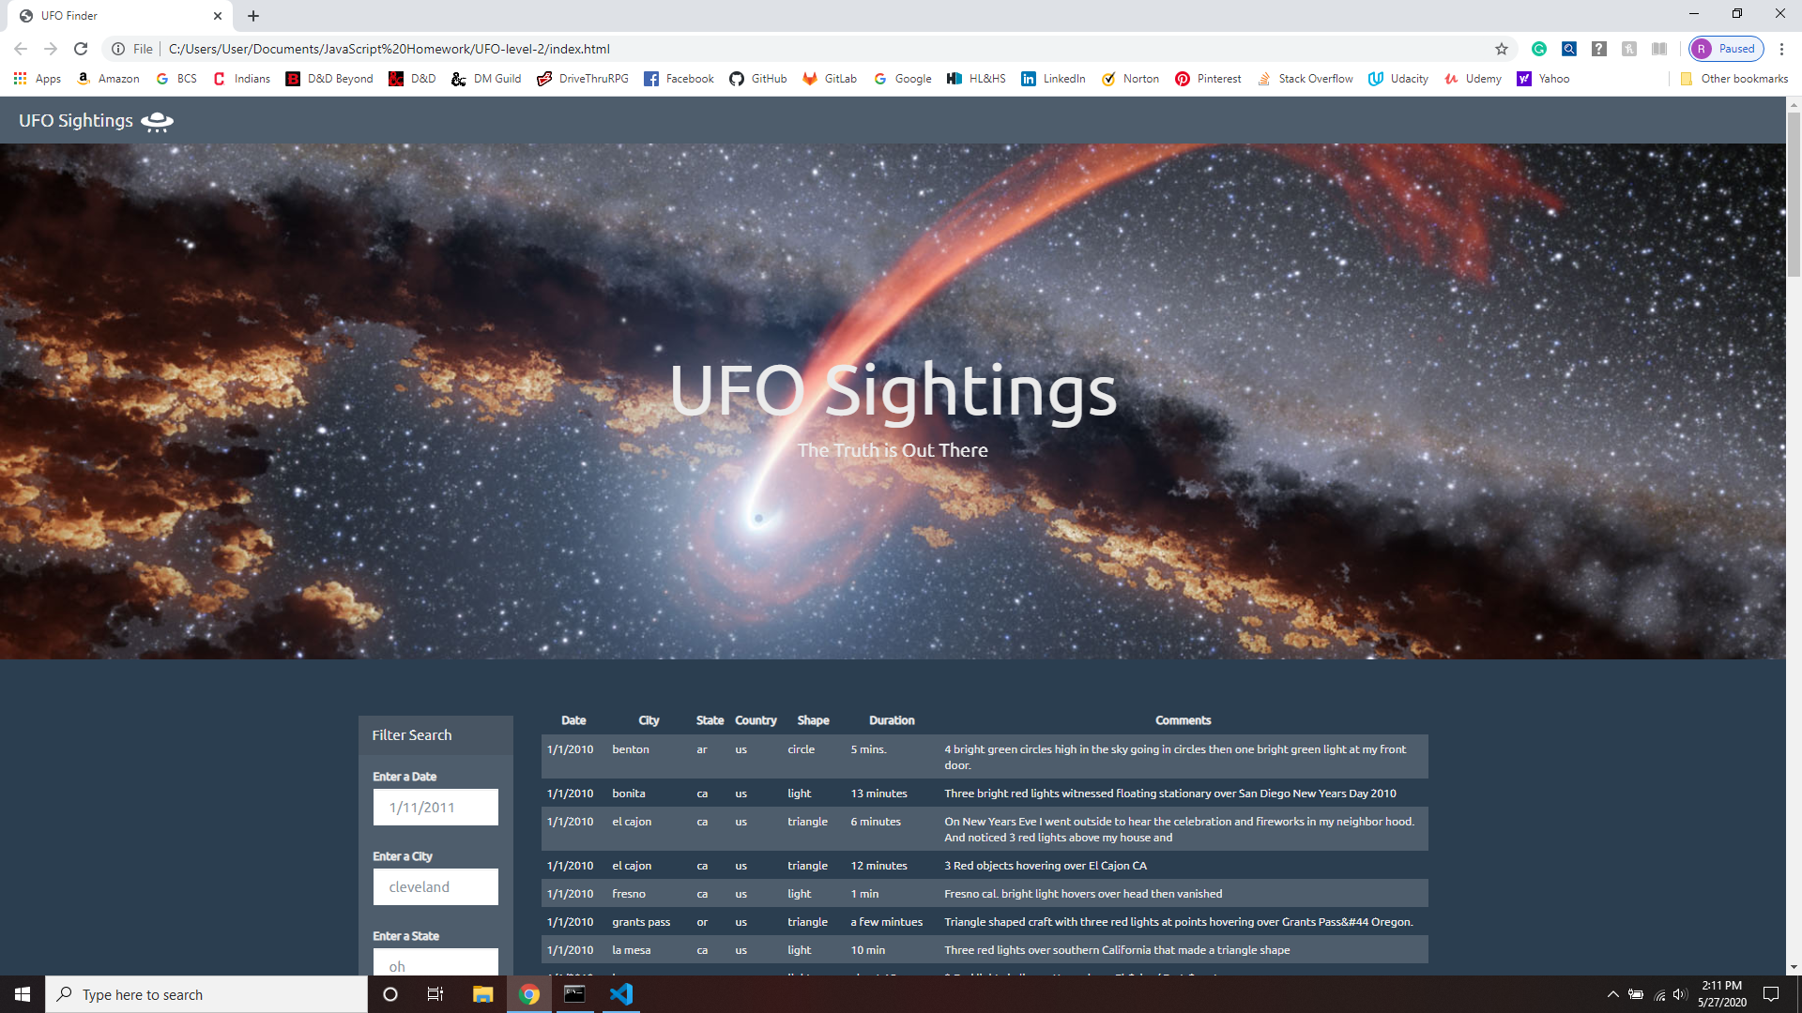

Level 2 search for sightings in state nm.

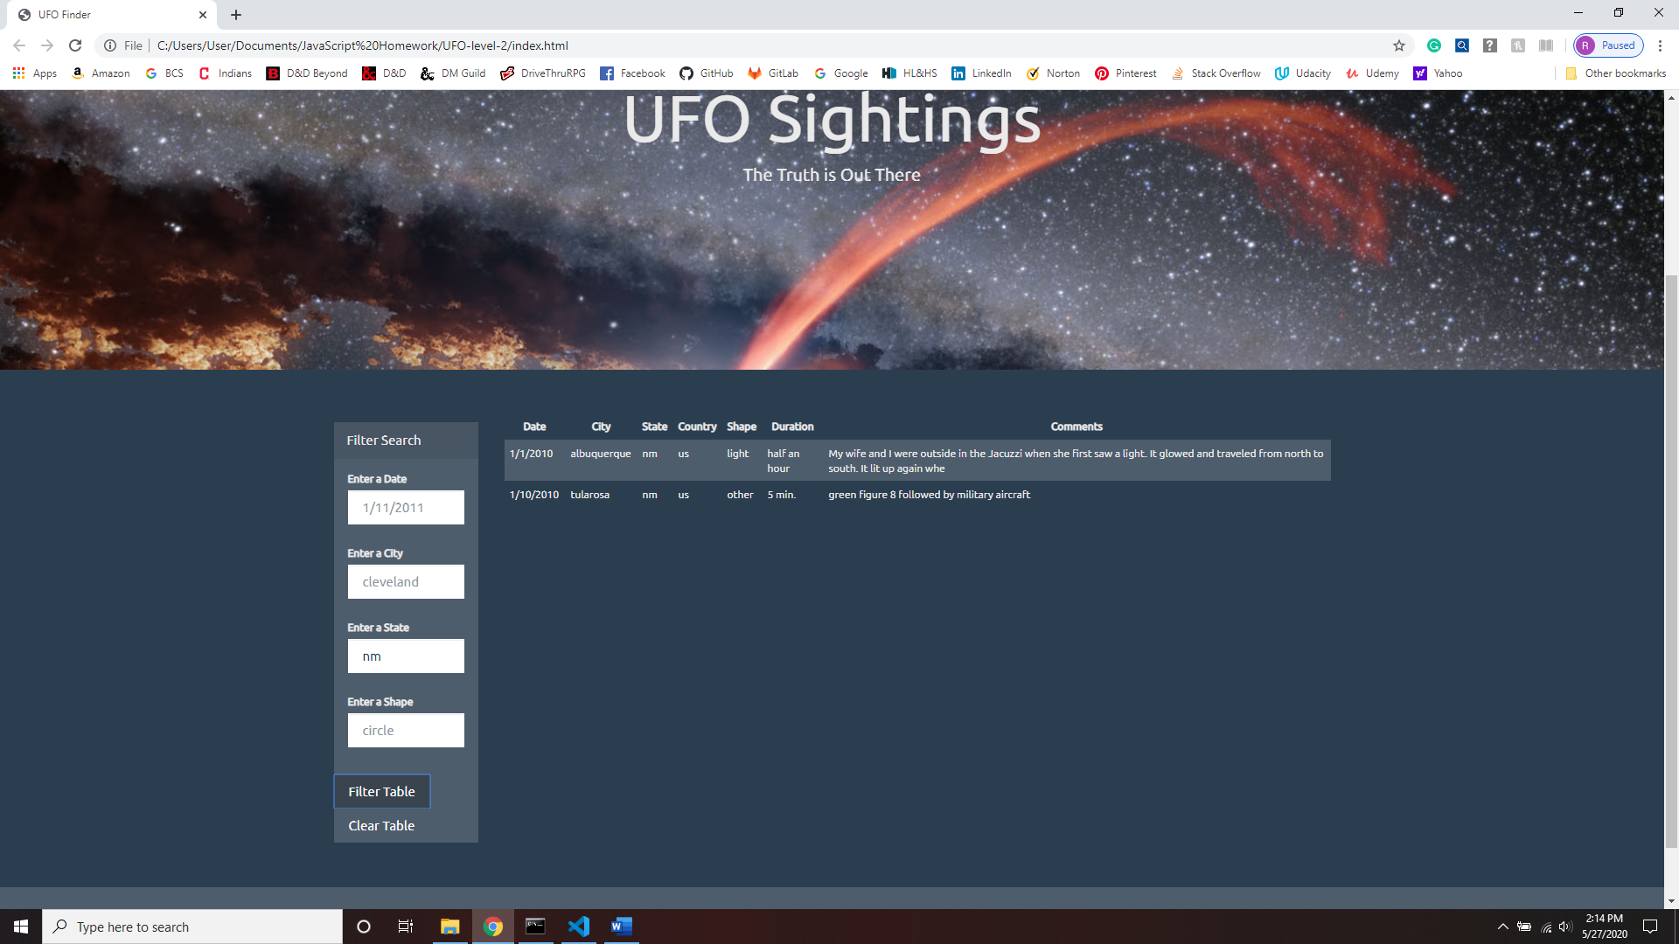

Level 2: clear filters and table

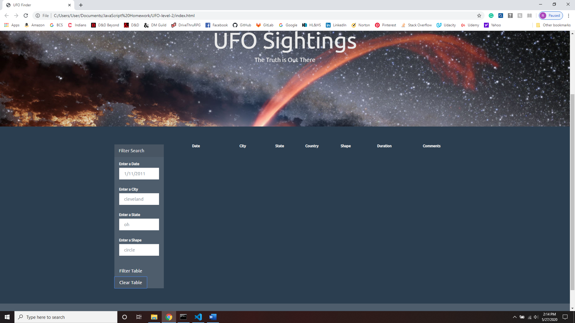

Level 2: New search: triangle shape

